CHAPTER 1

INTRODUCTION
Cloud computing is the delivery of computing services over the Internet. Cloud services allow individuals and businesses to use software and hardware that are managed by third parties at remote locations. Examples of cloud services include online file storage, social networking sites, webmail, and online business applications. The cloud computing model allows access to information and computer resources from anywhere that a network connection is available. Cloud computing provides a shared pool of resources, including data storage space, networks, computer processing power, and specialized corporate and user applications.
Many companies are delivering services from the cloud. Some notable examples as of 2010 include the following:
• Google:
Has a private cloud that it uses for delivering many different services to its users, including email access, document applications, text translations, maps, web analytics, and much more.
• Microsoft:
Has Microsoft® SharePoint® online service that allows for content and business intelligence tools to be moved into the cloud, and Microsoft currently makes its office applications available in a cloud.
• Salesforce.com:
Runs its application set for its customers in a cloud, and its Force.com and Vmforce.com products provide developers with platforms to build customized cloud services.

Characteristics:
Cloud computing has a variety of characteristics, with the main ones being:
• Shared Infrastructure:
Uses a virtualized software model, enabling the sharing of physical services, storage, and networking capabilities. The cloud infrastructure, regardless of deployment model, seeks to make the most of the available infrastructure across a number of users.
• Dynamic Provisioning:
Allows for the provision of services based on current demand requirements. This is done automatically using software automation, enabling the expansion and contraction of service capability, as needed. This dynamic scaling needs to be done while maintaining high levels of reliability and security.
• Network Access:
Needs to be accessed across the internet from a broad range of devices such as PCs, laptops, and mobile devices, using standards-based APIs (for example, ones based on HTTP). Deployments of services in the cloud include everything from using business applications to the latest application on the newest smartphones.
• Managed Metering:
Uses metering for managing and optimizing the service and to provide reporting and billing information. In this way, consumers are billed for services according to how much they have actually used during the billing period.

In short, cloud computing allows for the sharing and scalable deployment of services, as needed, from almost any location, and for which the customer can be billed based on actual usage.
Service Models:
Once a cloud is established, how its cloud computing services are deployed in terms of business models can differ depending on requirements. The primary service models being deployed (see Figure 1) are commonly known as:

• Software as a Service (SaaS):
Consumers purchase the ability to access and use an application or service that is hosted in the cloud. A benchmark example of this is Salesforce.com, as discussed previously, where necessary information for the interaction between the consumer and the service is hosted as part of the service in the cloud.

• Platform as a Service (PaaS):
Consumers purchase access to the platforms, enabling them to deploy their own software and applications in the cloud. The operating systems and network access are not managed by the consumer, and there might be constraints as to which applications can be deployed.

• Infrastructure as a Service (IaaS):
Consumers control and manage the systems in terms of the operating systems, applications, storage, and network connectivity, but do not themselves control the cloud infrastructure.

Deployment Models:
Deploying cloud computing can differ depending on requirements, and the following four deployment models have been identified, each with specific characteristics that support the needs of the services and users of the clouds in particular ways.

• Private Cloud:
The cloud infrastructure has been deployed, and is maintained and operated for a specific organization. The operation may be in-house or with a third party on the premises.

• Community Cloud:
The cloud infrastructure is shared among a number of organizations with similar interests and requirements. This may help limit the capital expenditure costs for its establishment as the costs are shared among the organizations. The operation may be in-house or with a third party on the premises.

• Public Cloud:
The cloud infrastructure is available to the public on a commercial basis by a cloud service provider. This enables a consumer to develop and deploy a service in the cloud with very little financial outlay compared to the capital expenditure requirements normally associated with other deployment options.

• Hybrid Cloud:
The cloud infrastructure consists of a number of clouds of any type, but the clouds have the ability through their interfaces to allow data and/or applications to be moved from one cloud to another. This can be a combination of private and public clouds that support the requirement to retain some data in an organization, and also the need to offer services in the cloud.

Benefits:
The following are some of the possible benefits of cloud computing services and applications:

• Cost Savings:
Companies can reduce their capital expenditures and use operational expenditures for increasing their computing capabilities. This is a lower barrier to entry and also requires fewer in-house IT resources to provide system support.

• Scalability/Flexibility:
Companies can start with a small deployment and grow to a large deployment fairly rapidly, and then scale back if necessary. Also, the flexibility of cloud computing allows companies to use extra resources at peak times, enabling them to satisfy consumer demands.

• Reliability:
Services using multiple redundant sites can support business continuity and disaster recovery.

• Maintenance:
Cloud service providers do the system maintenance, and access is through APIs that do not require application installations onto PCs, thus further reducing maintenance requirements.

Challenges:
The following are some of the notable challenges associated with cloud computing, and although some of these may cause a slowdown when delivering more services in the cloud, most also can provide opportunities, if resolved with due care and attention in the planning stages.

• Security and Privacy:
Perhaps two of the more “hot button” issues surrounding cloud computing relate to storing and securing data, and monitoring the use of the cloud by the service providers. These issues are generally attributed to slowing the deployment of cloud services. These challenges can be addressed, for example, by storing the information internal to the organization, but allowing it to be used in the cloud. For this to occur, though, the security mechanisms between organization and the cloud need to be robust and a Hybrid cloud could support such a deployment.

• Lack of Standards:
Clouds have documented interfaces; however, no standards are associated with these, and thus it is unlikely that most clouds will be interoperable. The Open Grid Forum is developing an Open Cloud Computing Interface to resolve this issue and the Open Cloud Consortium is working on cloud computing standards and practices. The findings of these groups will need to mature, but it is not known whether they will address the needs of the people deploying the services and the specific interfaces these services need. However, keeping up to date on the latest standards as they evolve will allow them to be leveraged, if applicable.

1.1 Purpose
In today’s scenario, there is no practical availability of Data security and accountability; data handling can be outsourced by the direct cloud service provider (CSP) to other entities in the cloud and theses entities can also delegate the tasks to others, and so on.
Secondly, entities are allowed to join and leave the cloud in a flexible manner. As a result, data handling in the cloud goes through a complex and dynamic hierarchical service chain which does not exist in conventional environments.
Users need secured data and accountability of data usage logs transfer using pull and push logs via internet.

1.2 Scope
Empowers higher end security and data accountability and reliable way to store data over Cloud or File sharing websites. Proper data access logs with location and IP address. Data owner’s pass key required to download file.

1.3 Concept of CIA
CIA framework lies in its ability of maintaining lightweight and powerful accountability that combines aspects of access control, usage control and authentication. By means of the CIA, data owners can track not only whether or not the service-level agreements are being honored, but also enforce access and usage control rules as needed
- Push mode:
The push mode refers to logs being periodically sent to the data owner or stakeholder.

- Pull mode:
Pull mode refers to an alternative approach whereby the user (Or another authorized party) can retrieve the logs as needed.
CHAPTER 2

2.1 Literature review
Title : Provable Data Possession at Untrusted Stores
Authors : Giuseppe Ateniese, Randal Burns, Reza Curtmola
Publication: Proceedings of the 14th ACM Conference on Computer and
Communications Security CCS 2007)

Concept Discussed:
A model for provable data possession (PDP) that allows a client that has stored data at an untrusted server to verify that the server possesses the original data without retrieving it is introduced in this project. The model generates probabilistic proofs of possession by sampling random sets of blocks from the server, which drastically reduces I/O costs. In particular, the overhead at the server is low (or even constant), as opposed to linear in the size of the data.
Work Done:
The problem of verifying if an untrusted server stores a client’s data was focused in this paper. A model for provable data possession, in which it is desirable to minimize the file block accesses, the computation on the server, and the client-server communication has been provided.
Gap:
These schemes do not allow sampling are not practical when PDP is used to prove possession of large amounts of data. Such schemes also impose a significant I/O and computational burden on the server.

Title: Lineage Retrieval for Scientific Data Processing: A Survey
Authors: Rajendra Bose and James Frew
Publication: ACM Computing Surveys, Vol. 37, No. 1, March 2005.
Concept Discussed:
Scientific research relies as much on the dissemination and exchange of data sets as on the publication of conclusions. Accurately tracking the lineage (origin and subsequent processing history) of scientific data sets is thus imperative for the complete documentation of scientific work. Researchers are effectively prevented from determining, preserving, or providing the lineage of the computational data products they use and create, however, because of the lack of a definitive model for lineage retrieval and a poor fit between current data management tools and scientific software. Based on a comprehensive survey of lineage research and previous prototypes, a Meta model is being presented to help identify and assess the basic components of systems that provide lineage retrieval for scientific data products.
Work Done:
To organize the review, this project recognized several broad categories for data processing where the processing flow is controlled by command line entries, scripts or programs, DBMS queries, WFMS directives, or Web- or Grid services.
It is also realistic to consider scientific data processing workflows that involve various combinations of these categories. Because of this, interest in systems to help assemble scientific workflows continues. Lineage retrieval for such complex workflows will clearly present challenges. The Internet has heightened expectations for data consumers’ immediate gratification, including the ability to access, select, and download programs and data products at will, and track the status or shipping history of packages or other items at will.
In addition, low-cost commercial genealogy software now provides the ability to: easily create complex lineage charts, reports, and queries (for family trees).
At its best, lineage retrieval for scientific data processing will provide a mixture of these three concepts. Systems including lineage retrieval will ideally allow a potential data consumer to access and select a custom scientific program or data product and browse or query the lineage or processing history using comprehensive charts or diagrams before downloading.

Title: Decentralized Trust Management and Accountability in Federated Systems
Authors: B. Chun and A.C. Bavier
Publication: Proc. Ann. Hawaii Int’l Conf. System Sciences (HICSS), 2004.
Concept discussed:
Cloud computing has raised a range of important privacy and security issues. Such issues are due to the fact that, in the cloud, users’ data and applications reside—at least for a certain amount of time—on the cloud cluster which is owned and maintained by a third party. Concerns arise since in the cloud it is not always clear to individuals why their personal information is requested or how it will be used or passed on to other parties.
Work done:
To date, little work has been done in this space, in particular with respect to accountability. A system for end-to-end trust management and accountability problem in federated systems has been developed where the focus is mainly to leverage trust relationships for accountability, along with authentication and anomaly detection. Further, their solution requires third-party services to complete the monitoring and focuses on lower level monitoring of system resources.

Title: Accountability as a Way Forward for Privacy Protection in the Cloud
Authors: S. Pearson and A. Charlesworth
Publication: Proc. First Int’l Conf. Cloud Computing, 2009.
Concept discussed:
The data processed on clouds are often outsourced, leading to a number of issues related to accountability, including the handling of personally identifiable information. Such fears are becoming a significant barrier to the wide adoption of cloud services.

Work done:
Pearson et al. have proposed accountability mechanisms to address privacy concerns of end users [30] and then develop a privacy manager [31]. Their basic idea is that the user’s private data are sent to the cloud in an encrypted form, and the processing is done on the encrypted data. The output of the processing is deobfuscated by the privacy manager to reveal the correct result. However, the privacy manager provides only limited features in that it does not guarantee protection once the data are being disclosed.

CHAPTER 3
ANALYSIS
3.1 System Analysis:
3.1.1 Problem definition:
To enhance the security and account for the usage of the data distributed in the cloud being used by others.
3.1.2 Existing system:
To allay users’ concerns, it is essential to provide an effective mechanism for users to monitor the usage of their data in the cloud. For example, users need to be able to ensure that their data are handled according to the service level agreements made at the time they sign on for services in the cloud. Conventional access control approaches developed for closed domains such as databases and operating systems, or approaches using a centralized server in distributed environments, are not suitable, due to the following features characterizing cloud environments.

Disadvantages:
- Data handling can be outsourced by the direct cloud service provider (CSP) to other entities in the cloud and theses entities can also delegate the tasks to others, and so on. This is a disadvantage of the system.
- Entities are allowed to join and leave the cloud in a flexible manner. As a result, data handling in the cloud goes through a complex and dynamic hierarchical service chain which does not exist in conventional environments.

3.1.3 Proposed System:
A novel approach, namely Cloud Information Accountability (CIA) framework, based on the notion of information accountability is proposed in this project. Unlike privacy protection technologies which are built on the hide-it-or-lose-it perspective, information accountability focuses on keeping the data usage transparent and trackable. The proposed CIA framework provides end-to-end accountability in a highly distributed fashion. One of the main innovative features of the CIA framework lies in its ability of maintaining lightweight and powerful accountability that combines aspects of access control, usage control and authentication. By means of the CIA, data owners can track not only whether or not the service-level agreements are being honored, but also enforce access and usage control rules as needed. Associated with the accountability feature, we also develop two distinct modes for auditing: push mode and pull mode. The push mode refers to logs being periodically sent to the data owner or stakeholder while the pull mode refers to an alternative approach whereby the user (or another authorized party) can retrieve the logs as needed.
Advantages:
- This is a novel automatic and enforceable logging mechanism in the cloud.
- The proposed architecture is platform independent and highly decentralized, in that it does not require any dedicated authentication or storage system in place.
- A certain degree of usage control for the protected data after these are delivered to the receiver is being provided.
- The experiments are conducted on a real cloud test bed. The results demonstrate the efficiency, scalability, and granularity of our approach.

3.2 Requirement Analysis:

3.2.1 Functional Requirements:
The system is mainly concerned with ensuring distributed accountability for data sharing in the cloud. It should allow only authorized user to upload and download files. It should provide a safe and secure infrastructure for file sharing in the cloud.

3.2.2 Non-Functional Requirements:
The system should be user friendly and easy navigation should be possible. Privacy should be provided to the user with secure authorization and the files must be stored in such a way that it cannot be decrypted easily by anyone without proper credentials.

3.2.3 Hardware Specification
Processor | - | Intel Dual Core
Speed | - | 1.70 GHz
RAM | - | 2 GB
Hard Disk | - | 160 GB
Key Board | - | Standard Qwerty Keyboard
Mouse | - | Optical Mouse
Monitor | - | 15’’ VGA

3.2.4 Software Specification
Operating System | - | Windows 8(Client), Ubuntu 10.10 (Server)
Application Server | - | Tomcat 7.0
Cloud Platform | - | Redhat Openshift
Front End | - | HTML, CSS
Scripts | - | Shell Scripts, JavaScript
Server side Script | - | Java Server Pages
Database | - | MySQL 5.1
Database Connectivity | - | JDBC

3.2.5 Software Analysis
Java:
Java is a set of several computer software products and specifications from Sun Microsystems (which has since merged with Oracle Corporation), that together provide a system for developing application software and deploying it in a cross-platform computing environment. Java is used in a wide variety of computing platforms from embedded devices and mobile phones on the low end, to enterprise servers and supercomputers on the high end. While less common, Java applets are sometimes used to provide improved and secure functions while browsing the World Wide Web on desktop computers.
Writing in the Java programming language is the primary way to produce code that will be deployed as Java bytecode. There are, however, bytecode compilers available for other languages such as Ada, JavaScript, Python, and Ruby. Several new languages have been designed to run natively on the Java Virtual Machine (JVM), such as Scala, Clojure and Groovy. Java syntax borrows heavily from C and C++, but object-oriented features are modeled after Smalltalk and Objective-C. Java eliminates certain low-level constructs such as pointers and has a very simple memory model where every object is allocated on the heap and all variables of object types are references. Memory management is handled through integrated automatic garbage collection performed by the JVM.
MySQL:
MySQL is (as of 2008) the world's most widely used open source relational database management system (RDBMS) that runs as a server providing multi-user access to a number of databases. It is named after co-founder Michael Widenius' daughter, My. The SQL phrase stands for Structured Query Language.
The MySQL development project has made its source code available under the terms of the GNU General Public License, as well as under a variety of proprietary agreements. MySQL was owned and sponsored by a single for-profit firm, the Swedish company MySQL AB, now owned by Oracle Corporation.
MySQL is a popular choice of database for use in web applications, and is a central component of the widely used LAMP open source web application software stack (and other 'AMP' stacks). LAMP is an acronym for "Linux, Apache, MySQL, Perl/PHP/Python." Free-software-open source projects that require a full-featured database management system often use MySQL.
For commercial use, several paid editions are available, and offer additional functionality. Applications which use MySQL databases include: TYPO3, Joomla, WordPress, phpBB, MyBB, Drupal and other software. MySQL is also used in many high-profile, large-scale World Wide Web products.
JSP:
JavaServer Pages (JSP) is a technology that helps software developers create dynamically generated web pages based on HTML, XML, or other document types. Released in 1999 by Sun Microsystems, JSP is similar to PHP, but it uses the Java programming language.
To deploy and run JavaServer Pages, a compatible web server with a servlet container, such as Apache Tomcat or Jetty, is required.
Architecturally, JSP may be viewed as a high-level abstraction of Java servlets. JSPs are translated into servlets at runtime; each JSP's servlet is cached and re-used until the original JSP is modified.
JSP can be used independently or as the view component of a server-side model–view–controller design, normally with JavaBeans as the model and Java servlets (or a framework such as Apache Struts) as the controller. This is a type of Model 2 architecture.
JSP allows Java code and certain pre-defined actions to be interleaved with static web markup content, with the resulting page being compiled and executed on the server to deliver a document. The compiled pages, as well as any dependent Java libraries, use Java bytecode rather than a native software format. Like any other Java program.
JSPs are usually used to deliver HTML and XML documents, but through the use of OutputStream, they can deliver other types of data as well.
The Web container creates JSP implicit objects like pageContext, servletContext, session, request & response.

Cron:
Cron is the time-based job scheduler in Unix-like computer operating systems. Cron enables users to schedule jobs (commands or shell scripts) to run periodically at certain times or dates. It is commonly used to automate system maintenance or administration, though its general-purpose nature means that it can be used for other purposes, such as connecting to the Internet and downloading email.
OpenShift:
OpenShift is a cloud computing platform as a service product from Red Hat. A version for private cloud is named OpenShift Enterprise. The software that runs the service is open-sourced under the name OpenShift Origin, and is available on GitHub. Developers can use Git to deploy web applications in different languages on the platform. Uniquely, OpenShift also supports binary programs that are web applications, so long as they can run on Red Hat Enterprise Linux. This allows the use of arbitrary languages and frameworks. OpenShift takes care of maintaining the services underlying the application and scaling the application as needed.

CHAPTER 4

DESIGN

4.1 OVERALL DESIGN

Overall System Architecture

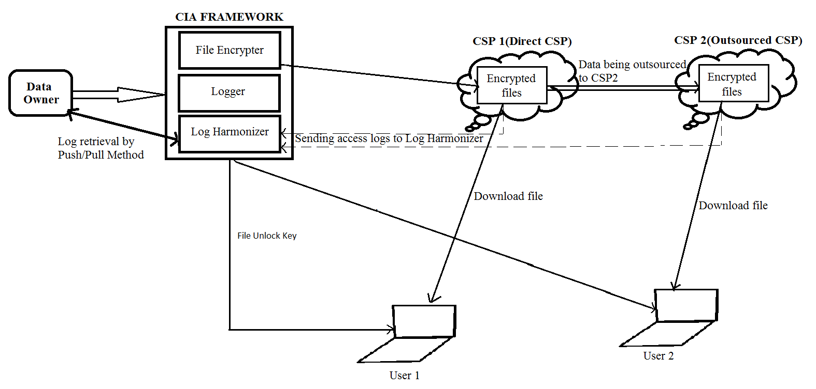

Fig 4.1.1 system architecture

4.2 DETAILED DESIGN

UML Diagrams

4.2.1 USECASE DIAGRAM

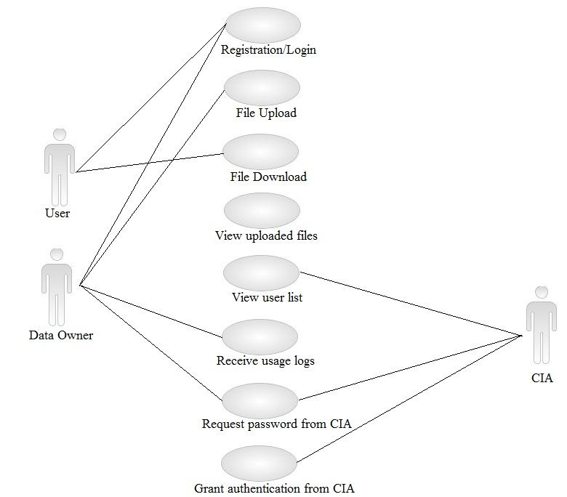

Fig 4.2.1 usecase diagram

4.2.2 ACTIVITY DIAGRAMS

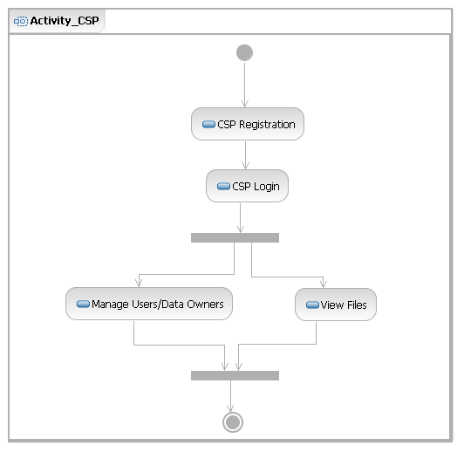
Fig 4.2.2.1 Activity diagram for Cloud Service Provider

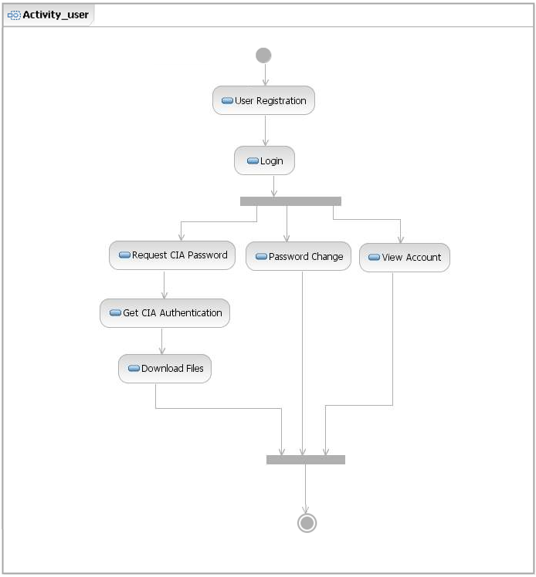

Fig 4.2.2.2 Activity diagram for user who downloads files

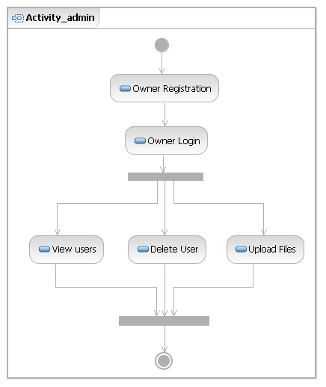
Fig 4.2.2.3 Activity diagram for Data owner

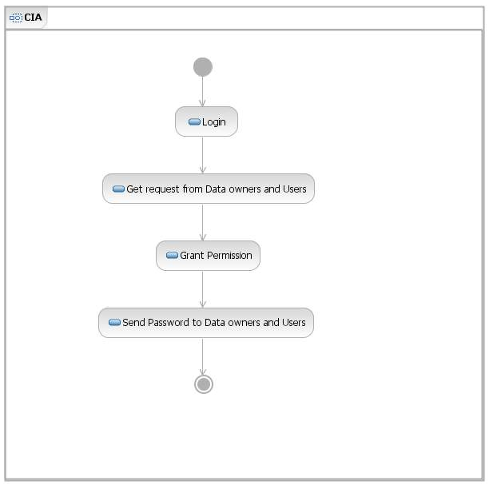

Fig 4.2.2.4 Activity diagram for Cloud Information Accountability Framework

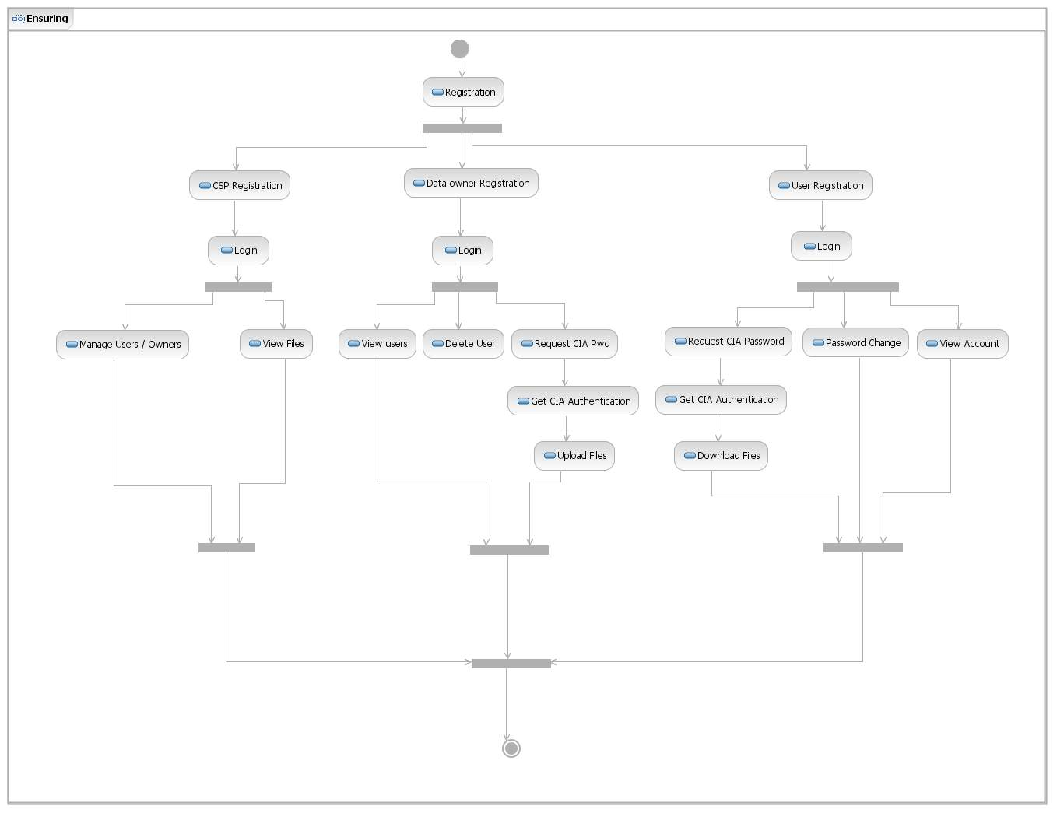
Fig 4.2.2.5 Overall Activity Diagram

4.2.3 SEQUENCE DIAGRAM

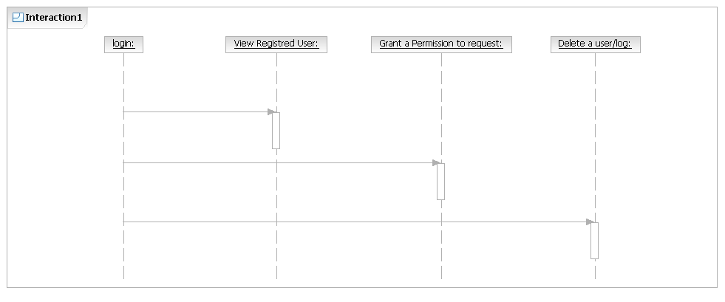
Fig 4.2.3.1 Interaction diagram for CIA framework

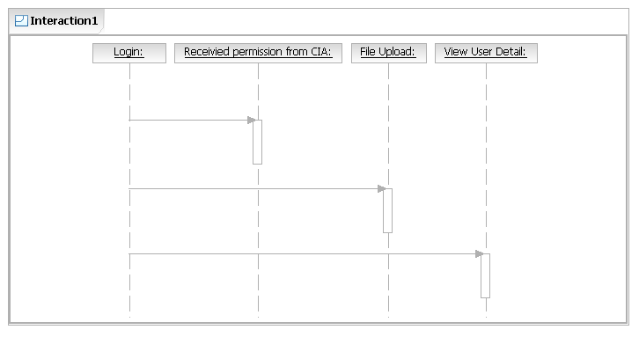
Fig 4.2.3.2 Interaction diagram for Data Owner

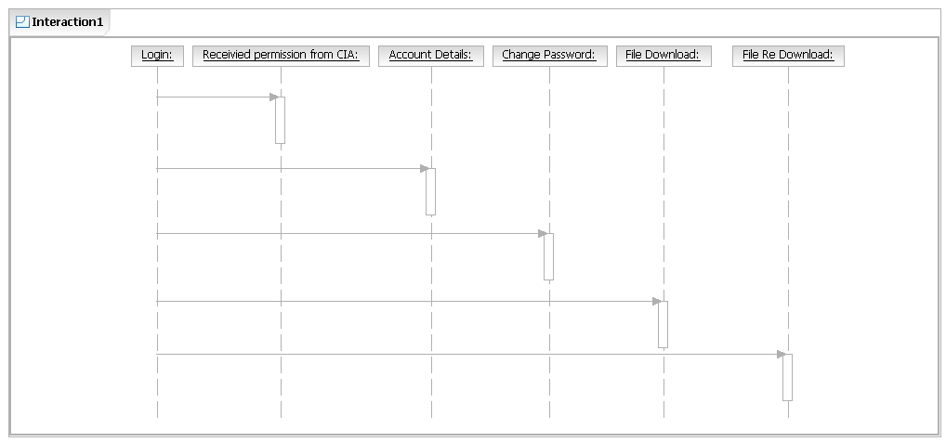
Fig 4.2.3.3 Interaction diagram for user

4.2.4 CLASS DIAGRAM:

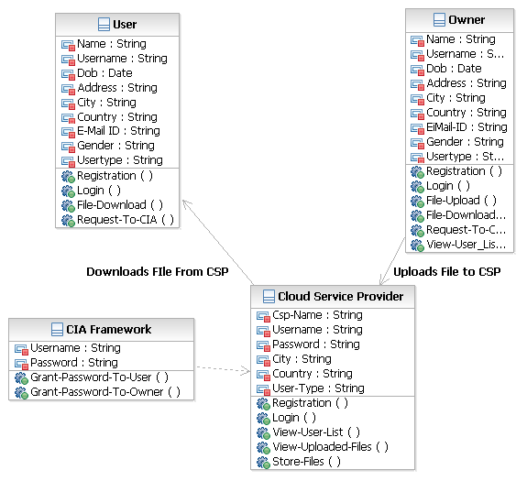

Fig 4.2.4 Class diagram

4.3 DETAILED DESIGN

METHOD : encrypt()

Scope | public
Parameters | InputStream, OutputStream
Return Value | void
Descriptions | Encrypts the file which is uploaded.
Calling Function | cipher.init ()
Called Function | CipherOutputStream ()

Table 4.3.1 Encrypt File

METHOD: decrypt()

Scope | public
Parameters | InputStream, OutputStream
Return Value | void
Descriptions | Decrypts the file while downloading.
Calling Function | cipher.init ()
Called Function | Cipher.update ()

Table 4.3.2 Decrypt File

METHOD: ServletFileUpload ()

Scope | public
Parameters | factory
Return Value | void
Descriptions | Uploads file
Calling Function | getInputStream()
Called Function | FileOutputStream(uploadedFile)

Table 4.3.3 File upload servlet
4.4 DATABASE DESIGN

SNO | Field Name | Field Type | Field Size | Description
1 | fileid | Integer | 20 | Unique file ID
2 | filename | Varchar | 20 | File name
3 | ownername | Varchar | 20 | Owner name
4 | uploadtime | Datetime | 20 | Time of file upload
5 | modeofpayment | Varchar | 20 | Mode of payment
6 | nameofthecard | Varchar | 20 | Card name
7 | accno | Interger | 11 | Account number
8 | expirydate | Varchar | 20 | Expiry Date
9 | cspname | Varchar | 20 | Cloud Service Provider Name
10 | username | Varchar | 20 | User name
11 | downloadtime | Datetime | 20 | Download time
12 | filekey | Varchar | 10 | File download key

Table 4.4.1 CIA Property

SNO | Field Name | Field Type | Field Size | Description
1 | ID | Integer | 20 | Unique file ID
2 | Name | Varchar | 20 | Login name
3 | Username | Varchar | 20 | username
4 | Email-id | Varchar | 20 | Email-ID of user
5 | Password | Varchar | 20 | Password
6 | Confirma Password | Varchar | 20 | Password Re-Type

Table 4.4.2 Login

1 | Username | Varchar | 20 | User name
2 | Password | Varchar | 20 | Password
3 | Usertype | Varchar | 20 | Type of user
4 | Status | Boolean | 10 | Permission grant status

Table 4.4.3 Request Table

1 | id | Integer | 10 | Identification number
2 | filename | Varchar | 25 | Name of file to upload
3 | file | blob | 4 Gb | File stored in database
4 | owner name | Varchar | 25 | Data owner name
5 | utime | Varchar | 10 | File upload time
6 | filekey | Varchar | 25 | File key

Table 4.4.4 Upload Table

4.3 ALGORITHM:
DES Algorithm:
- The main parts of the algorithm are as follows:
- Fractioning of the text into 64-bit (8 octet) blocks;
- Initial permutation of blocks;
- Breakdown of the blocks into two parts: left and right, named L and R;
- Permutation and substitution steps repeated 16 times (called rounds);
- Re-joining of the left and right parts then inverse initial permutation.
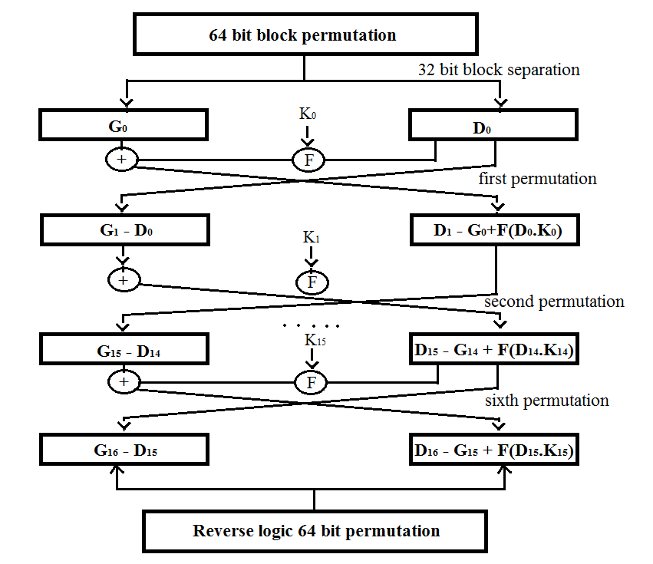
Fig 4.3.1 DES algorithm
Pseudocode
Cipher(plainBlock[64],RoundKeys[64,48],cipherBlock[64])
{
permute(64,64,plainBlock,inBlock,InitialPermulationTable)
split(64,32,inBlock,left,rightBlock)
for(round = 1 or 16)
{
mixer(leftBlock,rightBlock,RoundKeys[round])
if(round!16)swapper(leftBlock,rightBlock)
}
combine(32,64,leftBlock,rightBlock,outBlock)
permute(64,64,outBlock,cipherBlock,FinalPermulationTable)
}
mixer(leftBlock[48],rightBlock[48],RoundKeys[48])
{
copy(32,rightBlock,T1)
function(t1,RoundKey,T2)
exclusiveOr(32,leftBlock,T2,T3)
copy(32,T3,rightBlock)
}
swapper(leftBlock[32],rightBlock[32])
{
copy(32,leftBlock,T)
copy(32,rightBlock,leftBlock)
copy(32,T,rightBlock)
}

function(inBlock[32],RoundKey[48],outBlock[32])
{
permute(32,48,inBlock,T1,ExpansinPermulationTable)
exclusiveOr(48,T1,RoundKey,T2)
substitute(T2,T3,substituteTables)
permute(32,32,T3,outBlock,StraightPermulationTable)
}
substitute(inBlock[32,outBlock[48],SubstitutionTables[8,4,16])
{
for(i=1 to 8)
{
row<-2*inBlock[i*6+1]+inBlock[i*6+6]
col<-8*inBlock[i*6+2]+4*inBlock[i*6+3]+2*inBlock[i*6+4]+inBlock[i*6+5]
value=SubstitutionTables[i][row][col]
outBlock[[i*4+1]<-value/8; value <- value mod 8
outBlock[[i*4+2]<-value/4; value <- value mod 4
outBlock[[i*4+3]<-value/2; value <- value mod 2
outBlock[[i*4+1]<-value
}
}

Push/Pull Algorithm:
Pushing or pulling strategies have interesting trade-offs. The pushing strategy is beneficial when there are a large number of accesses to the data within a short period of time. In this case, if the data are not pushed out frequently enough, the log file may become very large, which may increase cost of operations like copying data. The pushing mode may be preferred by data owners who are organizations and need to keep track of the data usage consistently over time. For such data owners, receiving the logs automatically can lighten the load of the data analysers.

To implement push/pull algorithm we use CRON, a time based job scheduler.
Cron:
Cron is the time-based job scheduler in Unix-like computer operating systems. Cron enables users to schedule jobs (commands or shell scripts) to run periodically at certain times or dates. It is commonly used to automate system maintenance or administration, though its general-purpose nature means that it can be used for other purposes, such as connecting to the Internet and downloading email. The name cron comes from the Greek word χρόνος [chronos] for time.
Hourly Script:
#!/bin/bash
mail -s "Usage Log" <email>@gmail.com < /var/lib/openshift/515516b35973cae68c00019f/app-root/data/cronlogs/sql.log
cd ../../..
Minutely Script:
#!/bin/bash
mysql -t -h 127.8.1.1 -u adminsWtjE3x -p8h1kTabnsNwn -D cia -e "select filename,uploadtime,downloadtime,username,cspname from ciaproperty where ownername = '<ownername>';" >/var/lib/openshift/515516b35973cae68c00019f/app-root/data/cronlogs/sql.log
chmod +x sql
cd ../../..

CHAPTER 5
IMPLEMENTATION
5.1 MODULES
- Cloud Information Accountability (CIA) Framework
- Distinct modes for auditing
- Logging and auditing Techniques
- Logger and Log Harmonizer

MODULE DESCRIPTION
1. Cloud Information Accountability (CIA) Framework:
CIA framework lies in its ability of maintaining lightweight and powerful accountability that combines aspects of access control, usage control and authentication. By means of the CIA, data owners can track not only whether or not the service-level agreements are being honored, but also enforce access and usage control rules as needed.
2. Distinct modes for auditing:
Push mode:
The push mode refers to logs being periodically sent to the data owner or stakeholder.
Pull mode:
The pull mode refers to an alternative approach whereby the user
(Or another authorized party) can retrieve the logs as needed.
3. Logging and auditing Techniques:
1. The logging should be decentralized in order to adapt to the dynamic nature of the cloud. More specifically, log files should be tightly bounded with the corresponding data being controlled, and require minimal infrastructural support from any server.
2. Every access to the user’s data should be correctly and automatically logged. This requires integrated techniques to authenticate the entity who accesses the data, verify, and record the actual operations on the data as well as the time that the data have been accessed.
3. Log files should be reliable and tamper proof to avoid illegal insertion, deletion, and modification by malicious parties. Recovery mechanisms are also desirable to restore damaged log files caused by technical problems.
4. Log files should be sent back to their data owners periodically to inform them of the current usage of their data. More importantly, log files should be retrievable anytime by their data owners when needed regardless the location where the files are stored.
5. The proposed technique should not intrusively monitor data recipients’ systems, nor it should introduce heavy communication and computation overhead, which otherwise will hinder its feasibility and adoption in practice.

4. Logger and Log Harmonizer:
There are two major components of the CIA, the first being the logger, and the second being the log harmonizer.
The logger is strongly coupled with user’s data (either single or multiple data items). Its main tasks include automatically logging access to data items that it contains, encrypting the log record using the public key of the content owner, and periodically sending them to the log harmonizer. It may also be configured to ensure that access and usage control policies associated with the data are honored. For example, a data owner can specify that user X is only allowed to view but not to modify the data. The logger will control the data access even after it is downloaded by user X. The log harmonizer forms the central component which allows the user access to the log files. The log harmonizer is responsible for auditing.

CHAPTER 6
TESTING
Test ID | Test case description | Test case procedure | Input given | Expected Result | Actual Result
LOGIN PAGE :
T1 | To check whether the user enters valid username and password | User enters username and password | Username and password in the text box | Successful login | Login successful
REGISTRATION PAGE :
T2 | To check whether user enters proper mail ID | User enters his mail ID | sam@gmail | User should not be logged in | Enter proper mail id
T3 | To check whether user enters proper mail ID | User enters his mail ID | sam@gmail.com | User should be logged in | User mail ID verified and registered
T4 | To check weather mobile number is 10 digit | User enters his mobile number | 99454325 | Form submission must not be accepted | Mobile number must be of 10 digits
T5 | To check weather mobile number is 10 digit | User enters his mobile number | 9962888644 | Form submission must be accepted | Form data is submitted successfully
T6 | To fill all fields in the registration form | User does not fill all the fields | Mail ID left | Registration unsuccessful | Please fill all the fields
T7 | To fill all fields in the registration form. | User fills all the fields | All fields are filled. | Registration successful | All fields filled user registered successfully
DATA OWNER PAGE :
T8 | To upload file | To upload file to CSP | No request given for CIA password | CIA password should not be obtained. | NULL
T9 | To upload file | To upload file to CSP | Request given for CIA password | CIA password should be obtained. | CIA password obtained and file uploaded.
T10 | View user list | To view users who download files. | User has not registered in the system. | Name of the user does not appears on the list | No username is there in the list
T11 | View user list | To view users who download files. | User has registered in the system. | Name of the user appears on the list | Username appears in the list
T12 | CIA password | To get permission from CIA with Key. | NULL | Request not yet granted | NULL
T13 | CIA password | To get permission from CIA with Key. | NULL | Request granted | CIA password obtained from CIA admin.
T14 | To View files | To view the list of uploaded files | View files option selected | List of files uploaded. | List of files uploaded.
T15 | Download files | To download uploaded files | File download option is selected. | The file to be downloaded is selected and file key is entered | File is downloaded.
USER PAGE:
T16 | Change password | To change the existing password of user | Change password option selected | Password is not changed | Old password does not match
T17 | Change password | To change the existing user’s password. | Change password option selected. | Password changed. | Password changed.
T18 | CIA password | To get permission from CIA with Key. | NULL | Request not granted | NULL
T19 | CIA password | To get permission from CIA with Key. | NULL | Request granted | CIA password obtained.
T20 | Request to CIA | To request for permission from CIA | Authentication | Request passed to CIA | Request passed to CIA
T21 | Download Files | To download files from CSP | Password from CIA | Files to download | Authentication passed
T22 | File Download | To download file from CSP | File Key is entered | File is not downloaded | Wrong File key
T23 | File Download | To download file from CSP | File Key is entered | File is downloaded | File downloaded

CHAPTER 7
CONCLUSION:
We proposed innovative approaches for automatically logging any access to the data in the cloud together with an auditing mechanism. Our approach allows the data owner to not only audit his content but also enforce strong back-end protection if needed. Moreover, one of the main features of our work is that it enables the data owner to audit even those copies of its data that were made without his knowledge.

CHAPTER 8
FUTURE ENHANCEMENTS:
In the future, we plan to use a more efficient encryption algorithm like AES for data encryption. In the long term, we plan to design a comprehensive and more generic object-oriented approach to facilitate autonomous protection of traveling content. We also plan to create a system that verify the authenticity of the users by using phone verification. We would like to support a variety of security policies, like indexing policies for text files, usage control for executables, and generic accountability and provenance controls.

